|  |  |  |  |  |  |  |  |  |  |  |  |
| --- | --- | --- | --- | --- | --- | --- | --- | --- | --- | --- | --- |
| **Colour** | **m** | **ni** | **Left Deg** | **Left Min** | **Right Deg** | **Right Min** | **θ** | **λ (nm)** | **1/λ (m-1)** | **(1/4 - 1/ni2)** | **R (m-1)** |
| Violet | 1 | 5 | 193 | 42 | 223 | 50 | **15.07** | 433.24 | 2308200 | 0.2100 | (1.0991±0.0012)×10⁷ |
| Turquoise | 1 | 4 | 191 | 45 | 225 | 30 | **16.88** | 483.81 | 2066937 | 0.1875 | (1.1024±0.0011)×10⁷ |
| Red | 1 | 3 | 185 | 30 | 231 | 47 | **23.14** | 655.01 | 1526695 | 0.1389 | (1.0992±0.0007)×10⁷ |
| Violet | 2 | 5 | 177 | 26 | 239 | 56 | **31.25** | 432.31 | 2313149 | 0.2100 | (1.1015±0.0005)×10⁷ |
| Turquoise | 2 | 4 | 173 | 5 | 244 | 45 | **35.83** | 487.86 | 2049777 | 0.1875 | (1.0932±0.0004)×10⁷ |
| Red | 2 | 3 | 156 | 44 | 260 | 26 | **51.85** | 655.33 | 1525948 | 0.1389 | (1.0987±0.0003)×10⁷ |
| Violet | 3 | 5 | 157 | 19 | 259 | 26 | **51.06** | 432.10 | 2314260 | 0.2100 | (1.1020±0.0003)×10⁷ |

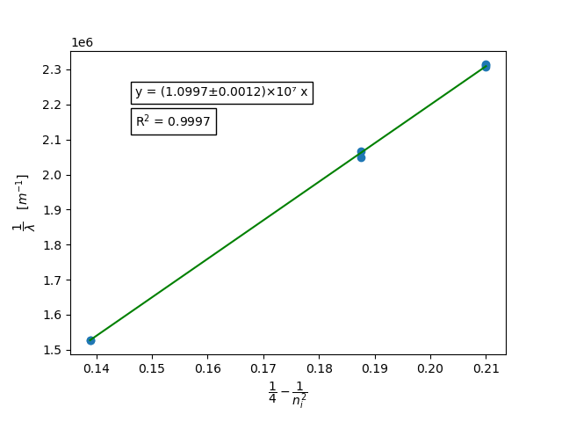

Average R = (1.0995±0.0003)×10⁷

Error from Literature Value = 0.19 %

R from graph = (1.0997±0.0012)×10⁷

Error from Literature Value = 0.21 %

All code can be found on my GitHub profile.

GitHub Username: TheReconPilot

Repository: IISER-Labs

Link: <https://github.com/TheReconPilot/IISER-Labs/tree/master/PHY%20222/Rydberg%20Constant>

Error analysis using Python’s *uncertainties* package

Graph plotted using *matplotlib* and *scipy*